
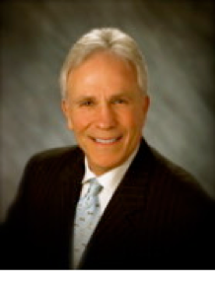

PRESS RELEASE
For Immediate Release

Nicholas Renna joins Telos Capital Advisors as Director of Business Development

Dallas, TX – February 1, 2021 – Telos Capital Advisors hired Nicholas Renna as Director of Business Development.
Mr. Renna brings with him over 40 years of experience in commercial lending and corporate banking. He has both domestic and international experience with many years working abroad. He worked at global institutions like HSBC, Citi, TD Securities and Texas predecessors’ of Bank of America.
In his roles, Mr. Renna assisted middle market businesses with their corporate and lending needs and led several multinational banking divisions. Bernard Carrico, Managing Director of Telos Capital Advisors said: “We're very excited to have Nick on board. His depth of experience, knowledge and business relationships will complement our team of seasoned executives.”
Telos Capital Advisors, LLC is a FINRA registered investment banking boutique serving lower middle market companies. Telos works with entrepreneurs to help them achieve their financial goals through a sale of their company or to raise capital. We assist established companies in raising equity or debt to fund growth, partial recapitalization, partner buyouts, acquisitions or to restructure the company’s balance sheet.
More information about Nicholas Renna is available at the company's Leadership page at https://teloscap.com/leadership/.

For additional information, contact:
Yola Portnoy, Director
YPortnoy@teloscap.com

